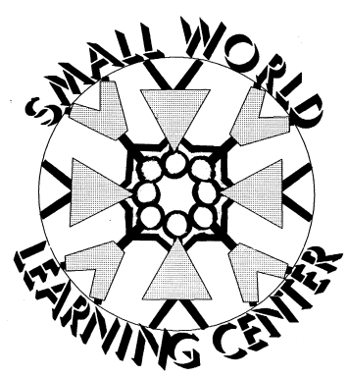
Illness Policy
This illness policy has been developed to ensure that all children who attend Small World remain healthy and safe.
When should your child be at home?
- Any child with a fever of 100.6 degrees or higher should not attend school. If your child develops a fever at the center he/she will have to be picked up as soon as possible and will be UNABLE to return to the center for 24-48 hours. No exceptions will be made!! We want to keep the children healthy!
- If your child has a severe cold (yellow or greenish discharge from the nose or throat), diarrhea, pink eye, thrush, strep throat, or any other childhood communicable disease he/she should also be kept home so as not to jeopardize the health of other children and staff. If your child develops ANY of these symptoms at the center you will be notified and he/she will need to be picked up as soon as possible. You must have alternate emergency numbers, in case you cannot be reached.
- If your child is unable to participate in the classroom’s daily activities he/she should not attend school. With temperatures above 32 degrees, we are required by D.C.F.S. to take the children outdoors.
Medication Administration
- Prescription Drugs- cannot be administered without a prescription consent form completely filled out and signed by parent. Prescription MUST come in original container; the label must contain the child’s first and last name, the physician’s name, the prescription number, the address and telephone number of physician, the dosage, and the date on which it was prescribed.
- Over the Counter- cannot be administered without a completed consent form signed by the parent. NO FEVER REDUCING MEDICATION WILL BE ADMINISTERED!!

Print Name_____________________________________Date______________________

Signature______________________________________

Child’s Name___________________________________

