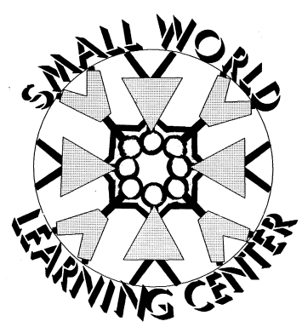
Dear Small World Parents,

Starting January of 2012, Small World will be using a developmental screening instrument on all children two months old to five years old. We will be using a valid and reliable screening tool called Ages & Stages which is a child-monitoring system for social-emotional behaviors in children. After completing this screening with the children we will hold a parent teacher conference to go over Ages & Stages as well as what is going on in your children’s classroom, and how your child is doing in class.

I __________________________________________________ agree to allow my child___________________________________________________ to be screened with Ages & Stages child-monitoring system.

